# Conversion BD Access vers MySQL

**1/ Utiliser outil BullZip pour générer script SQL**

Génère les create table (avec clés primaires)

Génère les insert into

**Modifier MyIsam en InnoDB**

**Attention aux types des données.**

**2/ Création des clés étrangères**

Ouvrir Access mode création (Touche appuyée sur Shift et double clic sur BD Access)

* Lancer visual Basic
* 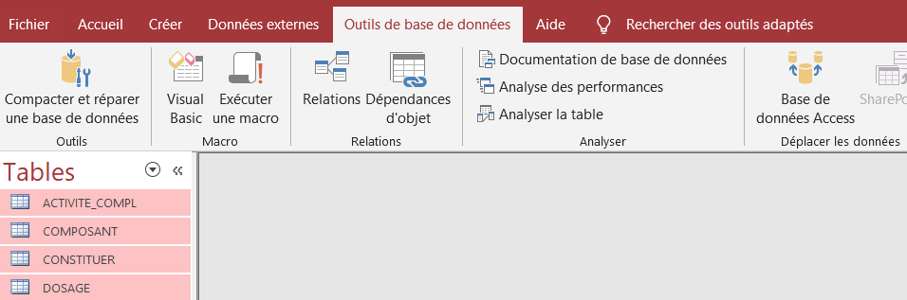
* Créer un module module 1 (insertion – module)

**Copier ce code :**

Option Compare Database

'Put this function in new/existing MS-Access module.

'' Version History:

'' 2014-02-09 - Seamus Casey

' a modification to Ivan's handy Access to MySQL relationship/constraint generator

'https://en.latindevelopers.com/ivancp/2012/ms-access-to-mysql-with-relationships/

' changes include:

' 1) skip Access system tables (TableDefAttributeEnum.dbSystemObjec)

' 2) add support for cascading updates/deletes

Public Sub printRelations()

Dim sql, fk As String

Dim I, J As Integer

Dim db As Database

Dim Table As TableDef

Dim TableName As String

' grab a reference to this once, otherwise when we retrieve a table below,

' we will get an 'Object Invalid or No Longer Set' error.

Set db = CurrentDb

For I = 0 To db.Relations.Count - 1

Set Table = db.TableDefs.Item(db.Relations(I).Table)

If ((Table.Attributes And TableDefAttributeEnum.dbSystemObject) = 0) Then

sql = "ALTER TABLE `" & db.Relations(I).ForeignTable & _

"` ADD CONSTRAINT `" & db.Relations(I).Name & "` FOREIGN KEY ("

fk = "("

For J = 0 To db.Relations(I).Fields.Count - 1

sql = sql & "`" & db.Relations(I).Fields(J).ForeignName & "` ,"

fk = fk & "`" & db.Relations(I).Fields(J).Name & "` ,"

Next J

sql = Left(sql, Len(sql) - 1)

fk = Left(fk, Len(fk) - 1)

fk = fk & ")"

sql = sql & ") REFERENCES `" & db.Relations(I).Table & "`" & fk

If (db.Relations(I).Attributes And RelationAttributeEnum.dbRelationUpdateCascade) Then

sql = sql & " ON UPDATE CASCADE"

End If

If (db.Relations(I).Attributes And RelationAttributeEnum.dbRelationDeleteCascade) Then

sql = sql & " ON DELETE CASCADE"

End If

sql = sql & ";"

Debug.Print sql

End If

Next I

End Sub

Exécuter le code

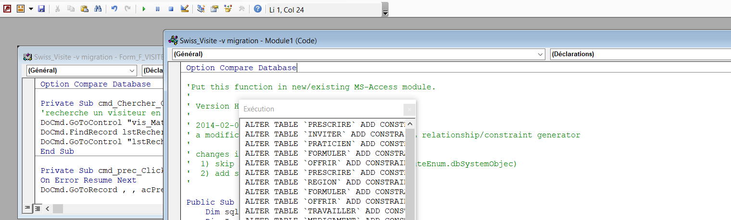

Afficher la fenêtre exécution

Copier les alter table dans un fichier script sql de notepad++. Changer le nom des contraintes

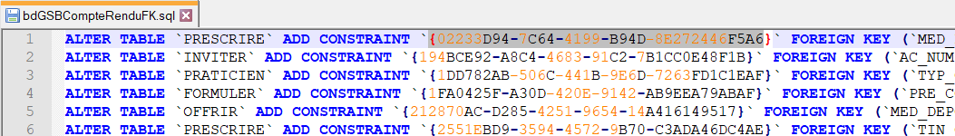

Exécuter le fichier dans MySql